**Google**

google ads

·' Google Ads

https//ads google com >

x

HO... .................. ................. _.,, -··::::r···-- "'''"' ......_._,_. _......... .....,

mobile apps, videos, and on non-search websites. Wikipedia

Initial release date: 23 October 2000

0 ... **0**

Google Ads - Get Customers and Sell More with Online ...

Reach customers wherever they are. Show up at the right time and place across the vast Google Ads ecosystem. Let Google's Al fird your best performing ad .

Stand out

Expert support - Goals - Keyword Planner - Explore Search Ads

Developer:Google

People also search for



View 10+ more

Keyword Planner

Get your ads to the right customers with Google's Keyword Planner ...

How it works

How to set up your first Google Ads campaign · Set up your ...

Video

How to advertise on YouTube ·Create a channel for your ... More results from google.com »

Google AdSense

Gmall Google Analytics

Google Search Console

Feedback

Google Support

G https://support.google.com > google-ads > aiswer

Create a Google Ads account: How to sign up

To get started with Google Ads,it just takes 3 simple steps: add your business information, select your campaign goals and budget, an:Ienter your payment ...

People also ask

Google Ads Goals Campaigns and Tools ., Partners ., Resources ., Expert support \., 1800-572 -8309* To help you get started with Google Ads, we'll give you 20,000 infree ad credit when you spend 20,000. Learn more

Sign in

**Drive sales**



Footwear Sale

**Expk>re** coilections



**with Google Ads.**

This site uses cookies from Google to deliver and enhance the quality of its services and to analyze traffic.

Learn more OK,got it

0



0

0

CoffeeIs art In every cup,and rlday Is the perfect day to enjoyIt.

 

Cappucino



!



#### Macch iato

*l*

#### Espresso

OROIR NOW

G 123-456-7890

#### @ www.reallyg reatslte.com

Position

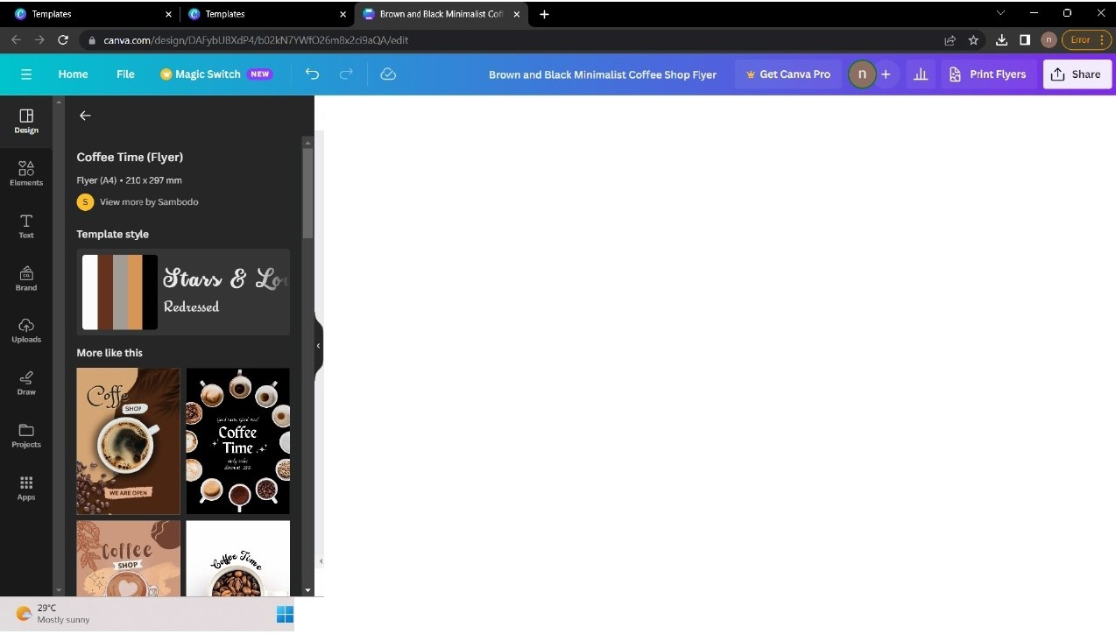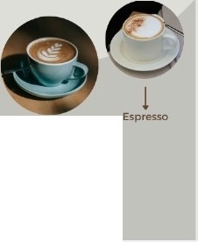

### 0

*s*

##### 0

0

Coffee 1$ ari '1 e ry cup, and

lday 1s the ptrfect day to enjOy It.

*7*

## !

Cappucino

## !

Macchiato

Notes

G+91

e

[www.reallygreatSlte .com](http://www.reallygreatSlte.com/)

Page 1/ 1 ----· 51% 00 ••

Q Search 0 -

00 0 0

Position



0

*s*

##### 0

0

Coffee 1$ ari '1 e ry cup, and

lday 1s the ptrfect day to enjOy It.

## !

Notes

G+91

www.reallygreatSlte .com

e

Page 1/ 1 ----·

51% 00 ••

Q Search 0 -

00 0 0

**Position**

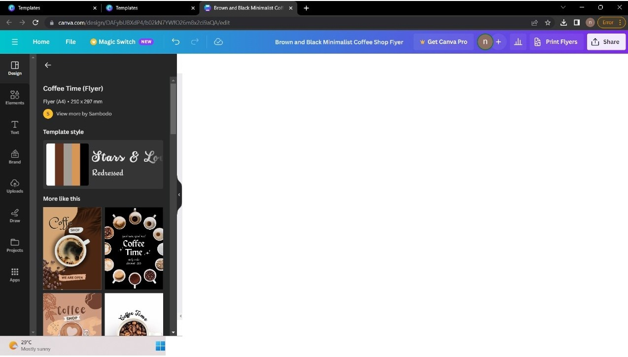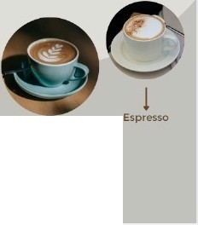

0

0

0

**Coffee ts an In every cup,and**

**l:tiday Isth**

*l*

Cappucino

***l***

Macchlato

Notes

,,..,..

G+91

@ www.reallygreat$lte.com

Page 1/ 1 ----·

52%

-

00 ••

Q Search

00 0 0

ENG ""' "')' = 10:39 •

**0**

**I!'**

IN 'B" "-"" .., **27 10·2023**

.. I

Google Ads

###### New campaign

.

|  |  |  |
| --- | --- | --- |
| (1) | 648-558-4944 Coffee Shop | n |
| Help | nmudhalvan220@gmai lcom |  |

t1'l Display

0 Add business information

0 Create your campaign

0 Choose goal

Targeting

People

Demographics

0 Choose campaign Suggest people based on age,gender,parentalstatus or household income <2>

* Campaign settings Edit targeted demographics Done
* Budget and bidding
* Targeting Demographics Optimised targeting
* Ads

0 Review

& Enter payment details

Gender Age Parental status Household income

**m** Female **m** 18 .24 **m** Not a parent 0 Top 10%

**m** Male **m** 25 - 34 **m** Parent 0 11 - 20%

**m** Unknown <2> **m** 35 - 44 0 Unknown <2> **m** 21 - 30%

**m** 45 - 54 **m** 31 - 40%

0 55 - 64 m 41 - 50%

0 65+ **m** Lower 50%

0 Unkrown <2> 0 Unknown <2>

A Note: Household income targeting is only available in select countries. Learn more

.. Google Ads New campaign (1)

648-558-4944 Coffee Shop [nmudhal](mailto:nmudhalvan220@gmad.com)[van220@gmad.com](mailto:van220@gmad.com)

I

Help n

91 Display

0 Add business information

0 Create your campaign

0 Choose goal

0 Choose campaign

* Campaign settings
* Budget and bidding
* Targeting Demographics Optimised targeting
* Ads

0 Review

l2J Enter payment details

Targeting

People

Demographics

Suggest people based on age, gender, parental status or household income

Targeted demographics

Age

18 - 24 + 3 more

Parental status Parent, Not a parent

Household income

21 - 30% + 3 more

Optimised targeting On v

All changes saved

0 Add targeting